MAGNET Field GCX2 Network Rover Configuration

Select JOB CONFIGURE SURVEY
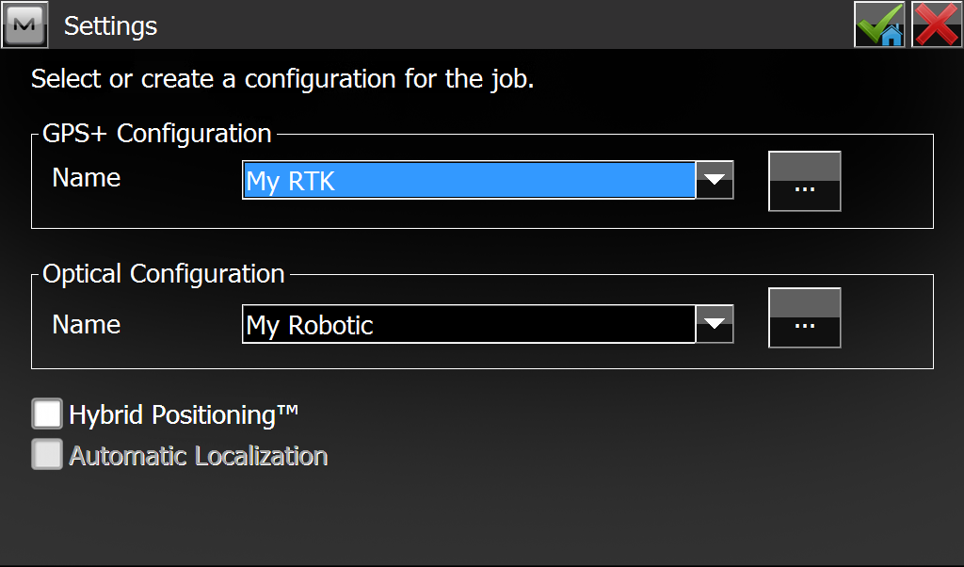

Select the ELLIPSIS (…) button.
Select ADD
Name the profile “GCX2 Network Rover”
Type = NETWORK RTK
Corrections = VRS (this could depend on the network you are connecting to)
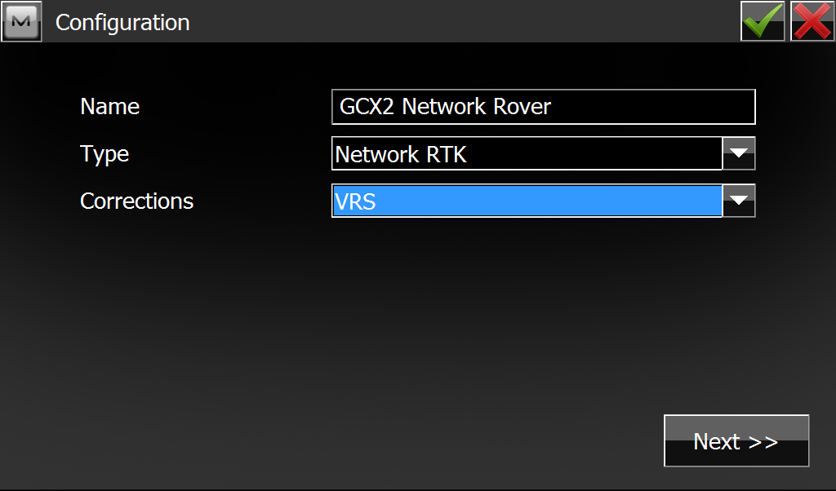

Press NEXT
Manufacturer = SOKKIA
Press NEXT
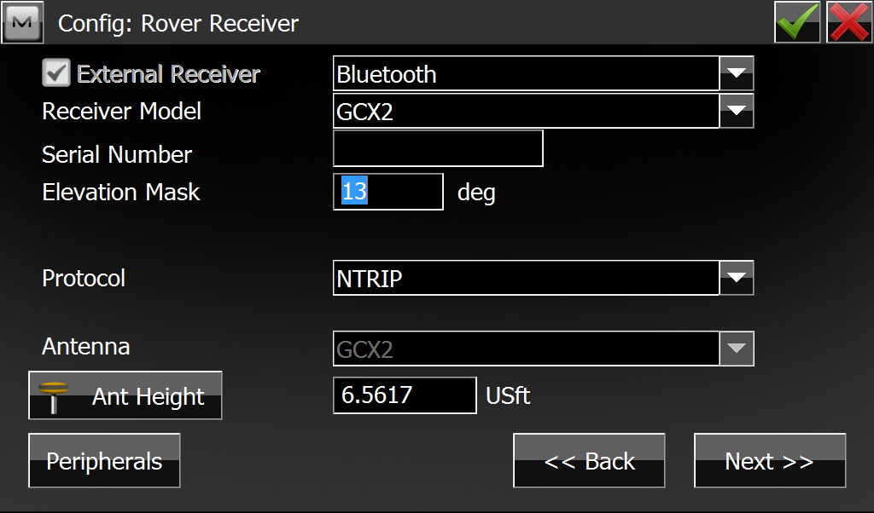

External Receiver = BLUETOOTH
Receiver Model = GCX2
Serial Number = <may leave blank if desired>
Elevation Mask = 13 deg (default)
Protocol = NTRIP (this by far is the most common internet RTK format)
Enter your Ant Height. Example: If you are using a fixed height 2m pole you will just enter 2m here. MAGNET will account for the receiver height offset.
Press NEXT

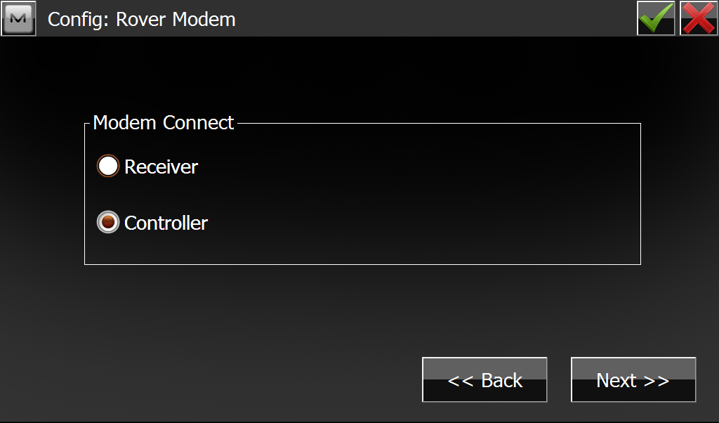
Modem Connect = CONTROLLER (we will use the internet on the data collector)
NEXT

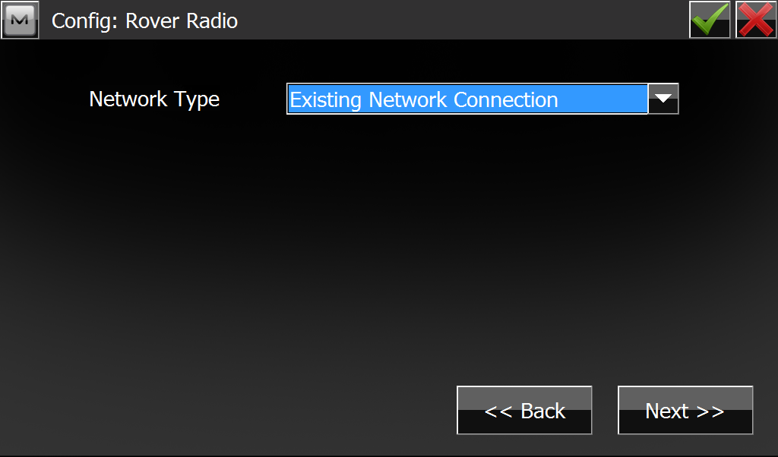
Network Type = EXISTING NETWORK CONNECTION
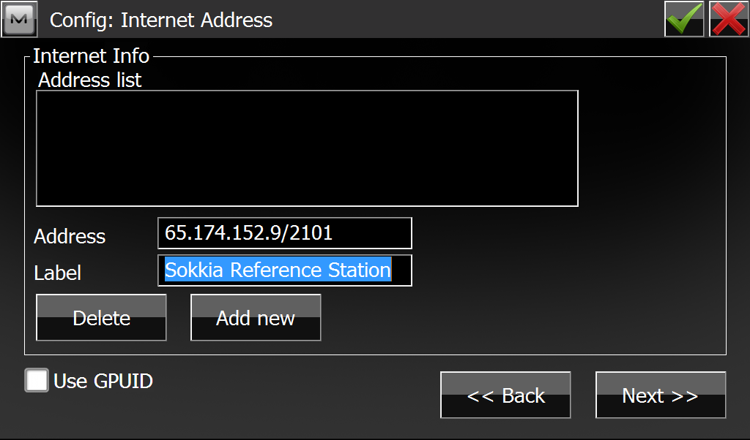
Address = Type in the IP Address of the network you are trying to connect to. Note the notation of the TCP port (X.X.X.X/PORT)
Label = Give the site a meaningful, descriptive name.
Press ADD NEW. The site should appear in the ADDRESS LIST.
Press NEXT
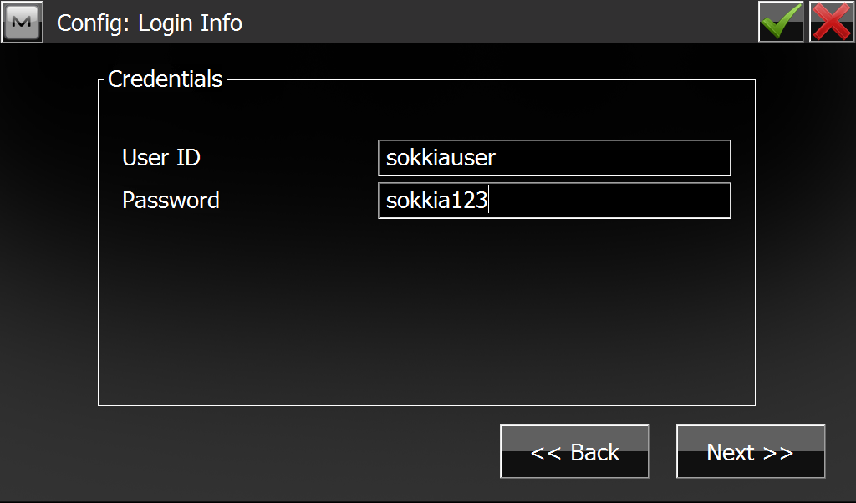
Enter the credentials to gain access to the network (given by network administrator)
Press NEXT
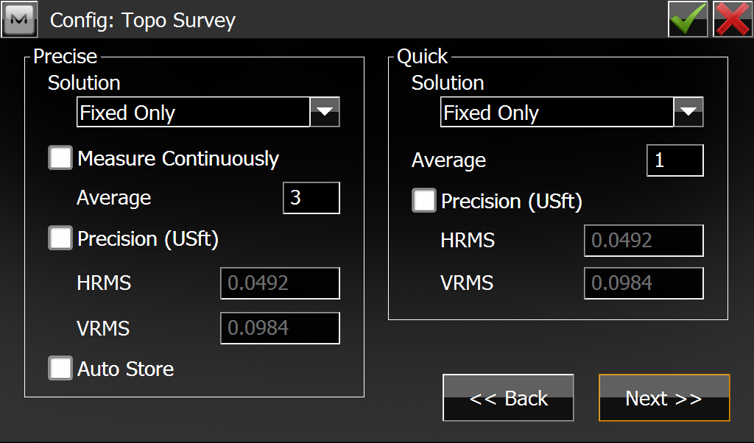
Press NEXT
Press the GREEN CHECKMARK TO COMPLETE THE PROFILE . We will leave everything else to default (best) settings.
From the MAIN MAGNET screen, press CONNECT.
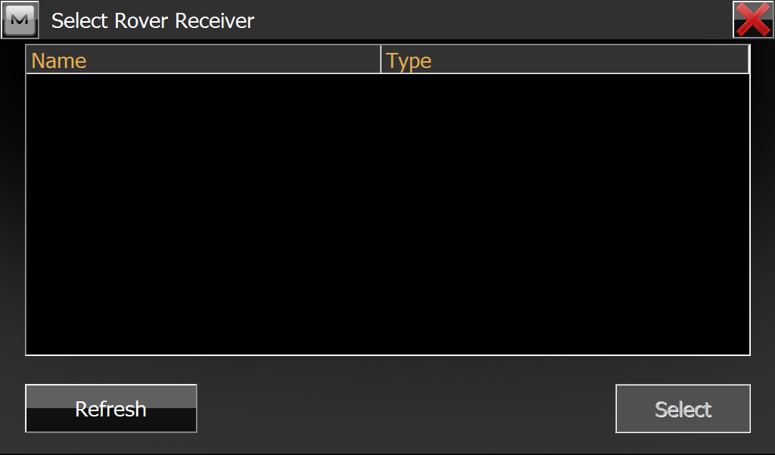
MAGNET will begin searching for your GCX2.
When if finds the GCX2, highlight it and press SELECT.
You will be presented with a NTRIP MOUNT POINT selection. Select the correct one for your location and press CONNECT.
After you have a successful connection, let’s jump into SURVEY TOPO to see a solution:

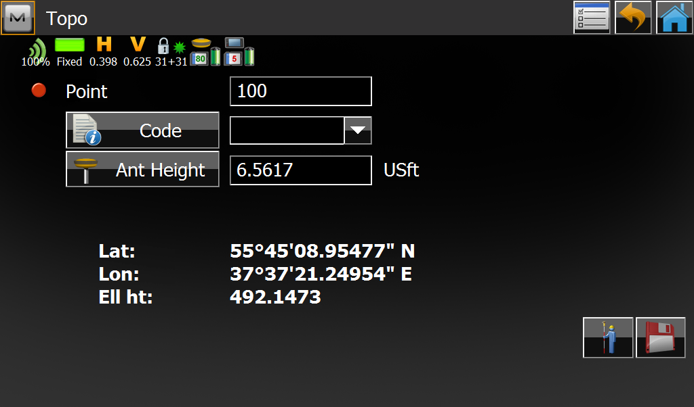

SUCCESS!!! Now you are ready to work.

